Project Design Phase-II
Data Flow Diagram & User Stories

Date | 03-12-2025
Project Name | Bookstore
Maximum Marks | 4 Marks

Data Flow Diagrams: A Data Flow Diagram (DFD) illustrates how data moves within the Online Multi-Vendor Bookstore Platform. It shows how readers (users) and sellers interact with the system, how book-related data flows between components, and how it is stored securely in the database.
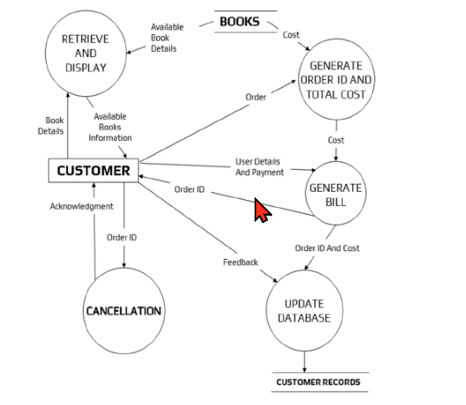

Note: This sample DFD represents the conceptual flow. For the Bookstore project, the modules correspond to user authentication, book browsing, book search & filtering, shopping cart, order placement, and payments.

User Stories

User Story Table –Bookstore Platform
User Type | Functional Requirement (Epic) | User Story / Task | Acceptance Criteria | Priority | Release
User |  | As a user, I can sign up and log in securely. | Login success redirects to homepage. | High | Sprint-1
  User Authentication
User |  | As a user, I can reset my password if forgotten. | Reset link sent and password updated. | Medium | Sprint-1
  Password Reset
User | Book Browsing & Search |  | Search returns relevant results instantly. | High | Sprint-2
  As a user, I can browse and search books by title, author, or category.
User | Book Details | As a user, I can view complete book details (price, author, description). | Correct book information is displayed. | Medium | Sprint-2
User | Shopping Cart | As a user, I can add books to the cart and proceed to checkout. | Cart updates and displays selected items. | High | Sprint-3
User | Payment & Order Placement | As a user, I can make secure payments and place orders. | Payment processed and order shown in history. | High | Sprint-3
User |  | As a user, I can view my previous orders and tracking status. | Order list displays accurately. | Medium | Sprint-6
  Order History
User | Review System | As a user, I can leave a review and rating for purchased books. | Review appears on the book page after submission. | Medium | Sprint-4
Admin | Seller/User Moderation | As an admin, I can approve sellers and manage users. | Status updates saved successfully. | High | Sprint-1

User stories are mapped to four sprints to ensure predictable delivery of key modules. High-priority features such as authentication and order placement are developed earlier, while medium-priority features such as reviews and order history are delivered in later sprints.

